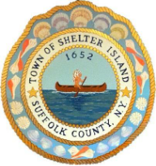

Town of Shelter Island
Board of Ethics

January 12, 2026
1 PM
(subject to change)

Work Session
- Review and approve December 4, 2025 Minutes
- Public comments
- Ethics Code update
- Plain English Guide

Executive Session

1. Discuss the employment history of several employees

Last update 01/__/26

